17.) cut -c 1 f2

This command is used to display the Characters present in 1st column

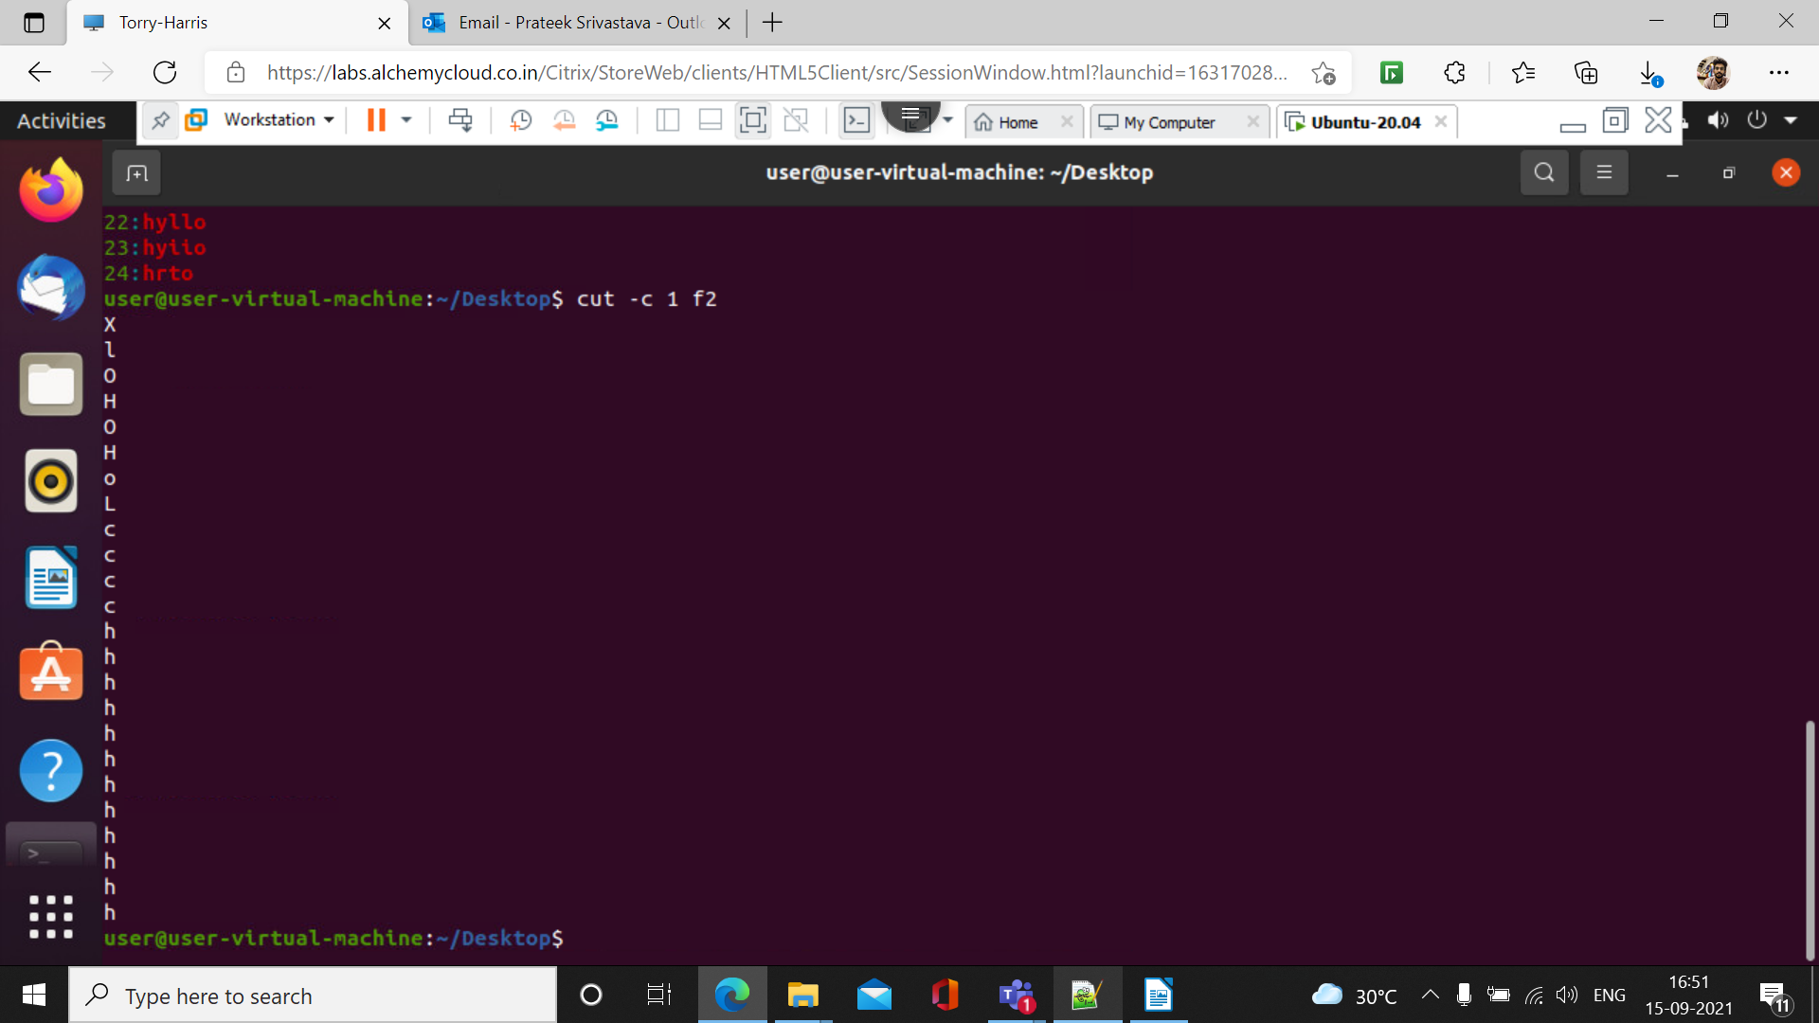
18.) cut -c 1,4 f2

This command is used to display 1st and 4th characters in a column

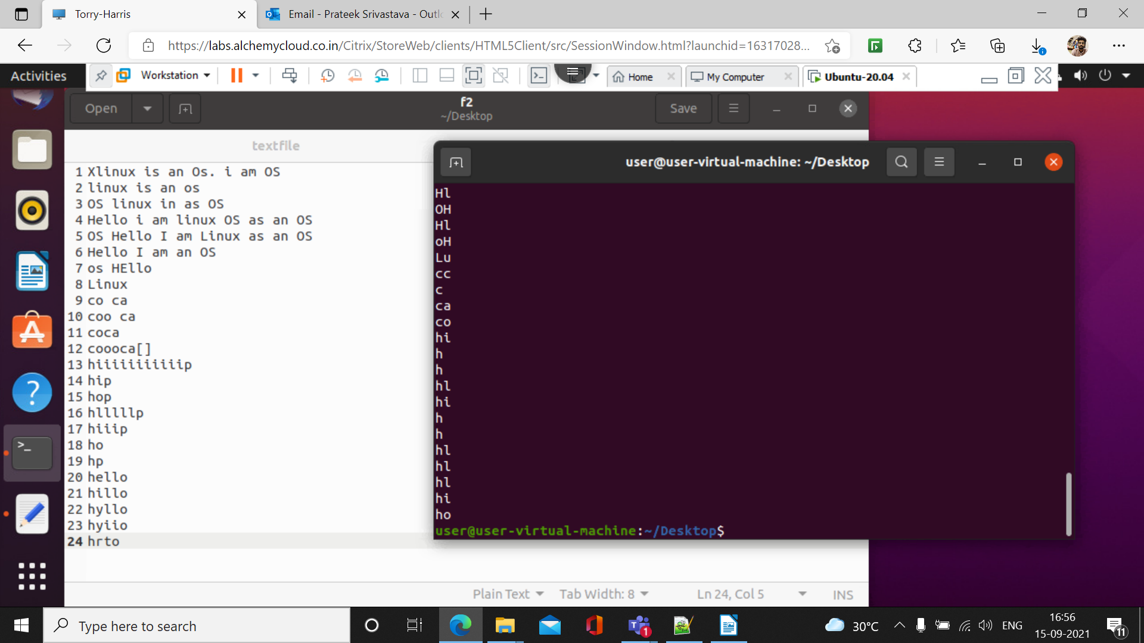

19.) cut -c 4- f2

This command is used to display all the text present after the 4th column

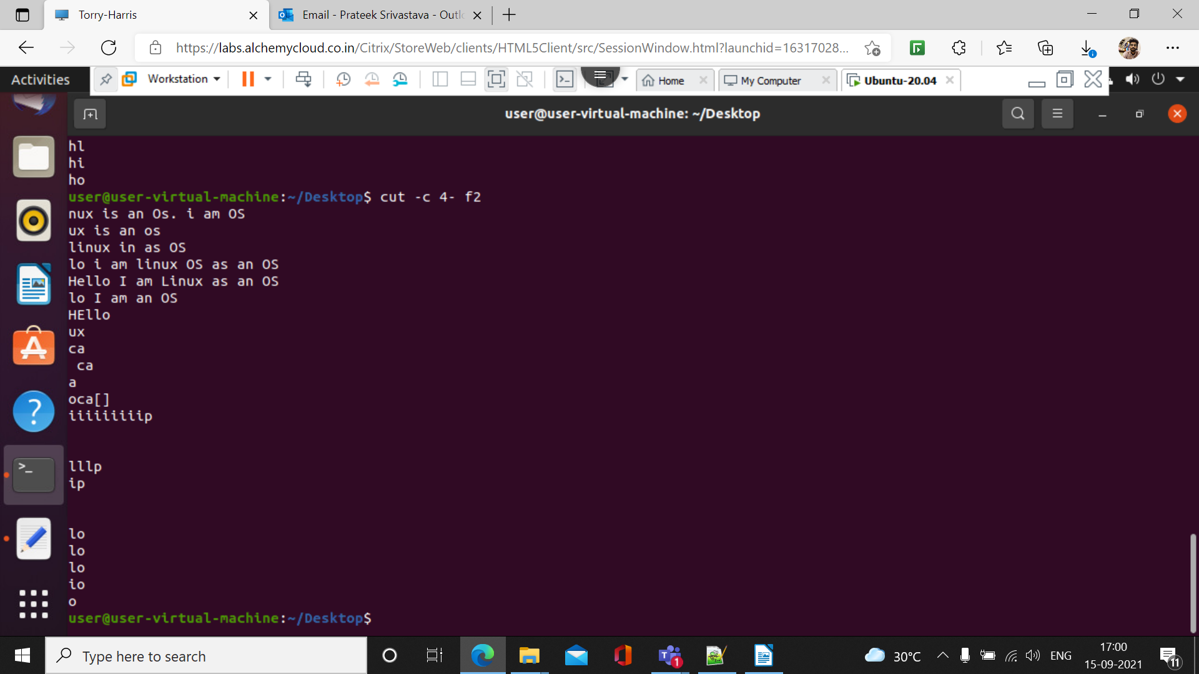
20.) cut -c -5 f2

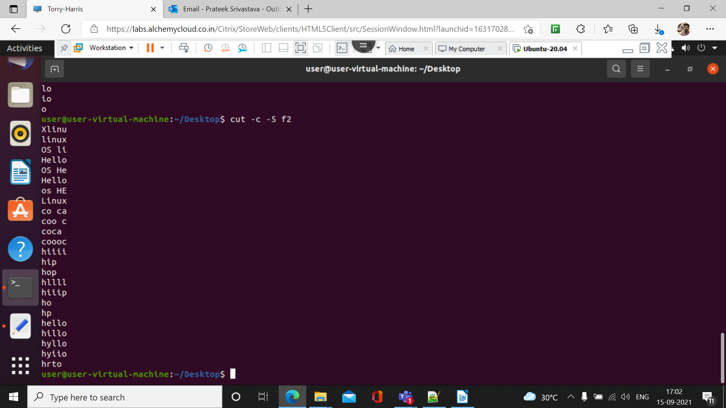

21.) cut -b 5 – 9 f2

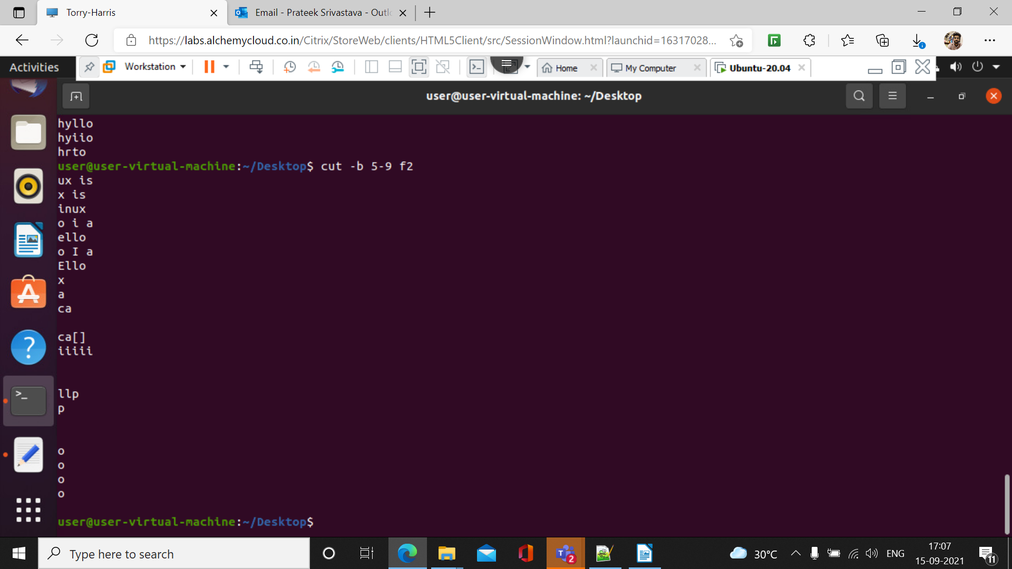
22,) cut -d ‘s’ -f 1 f2

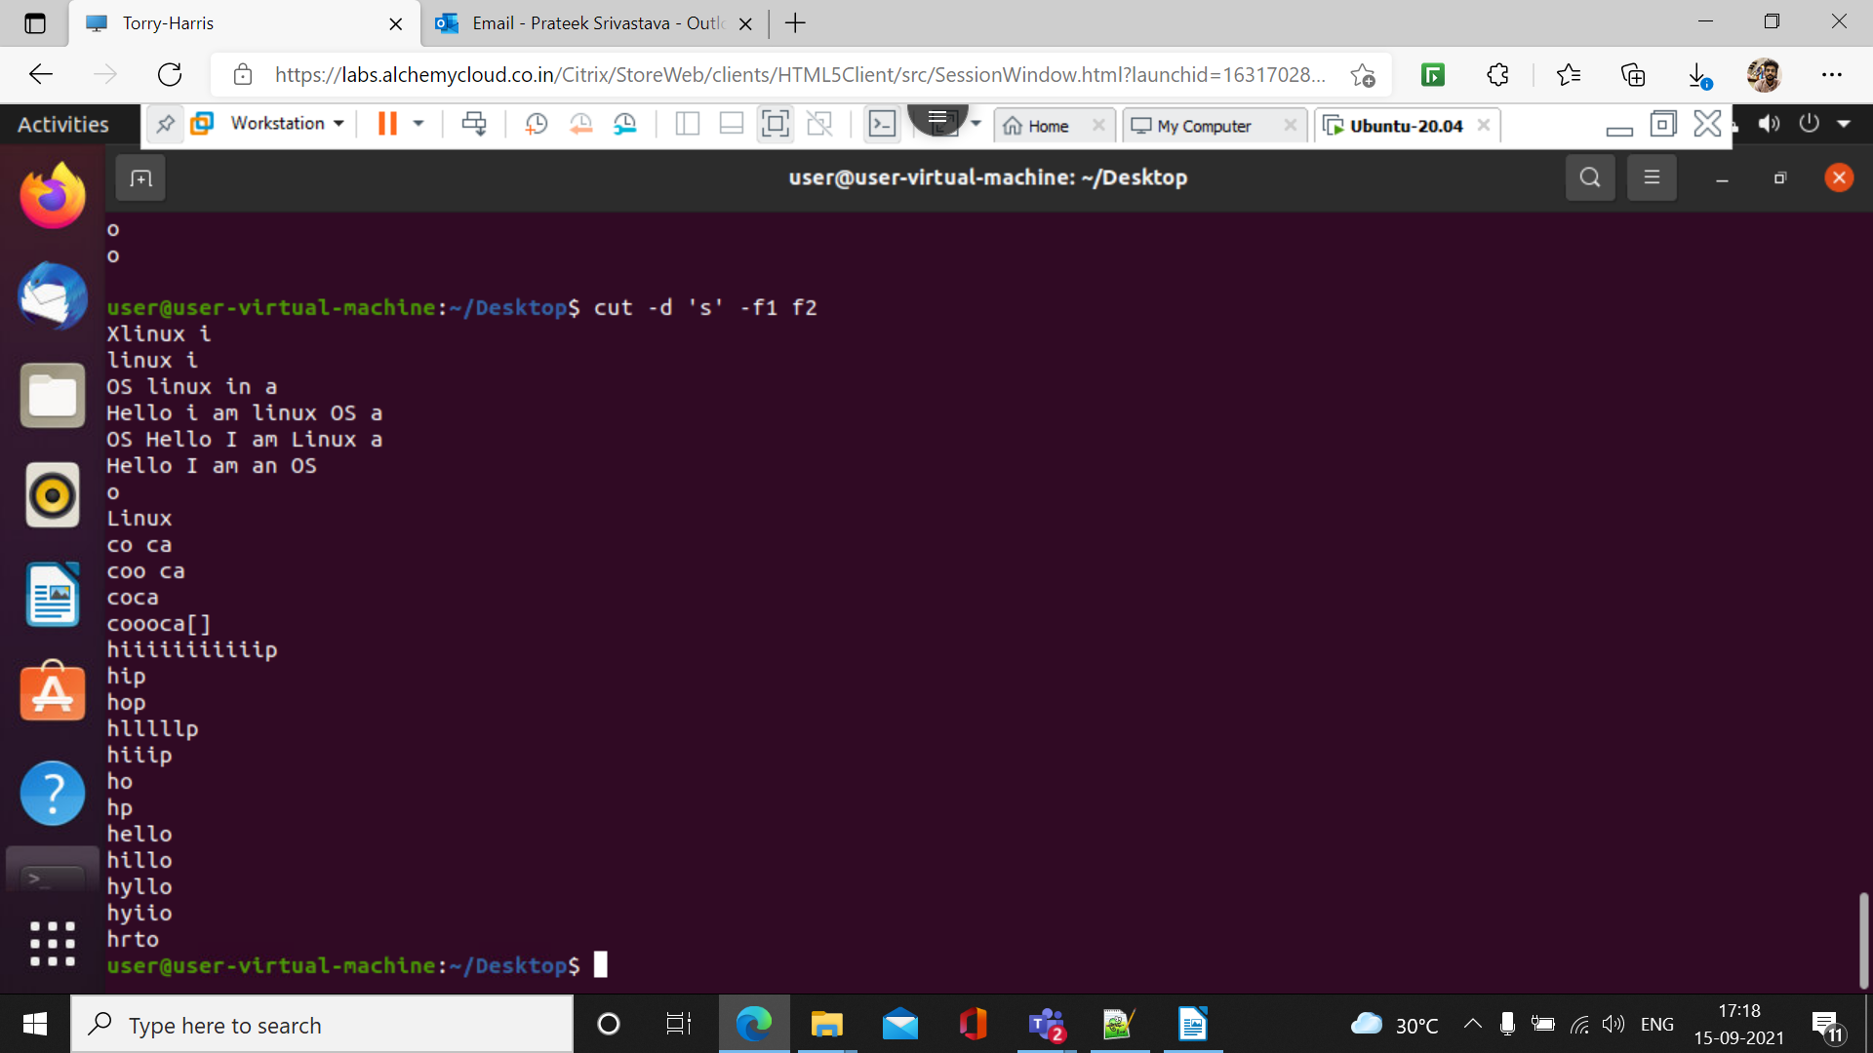
23.) cut - c 2 – 4, 6 – f2

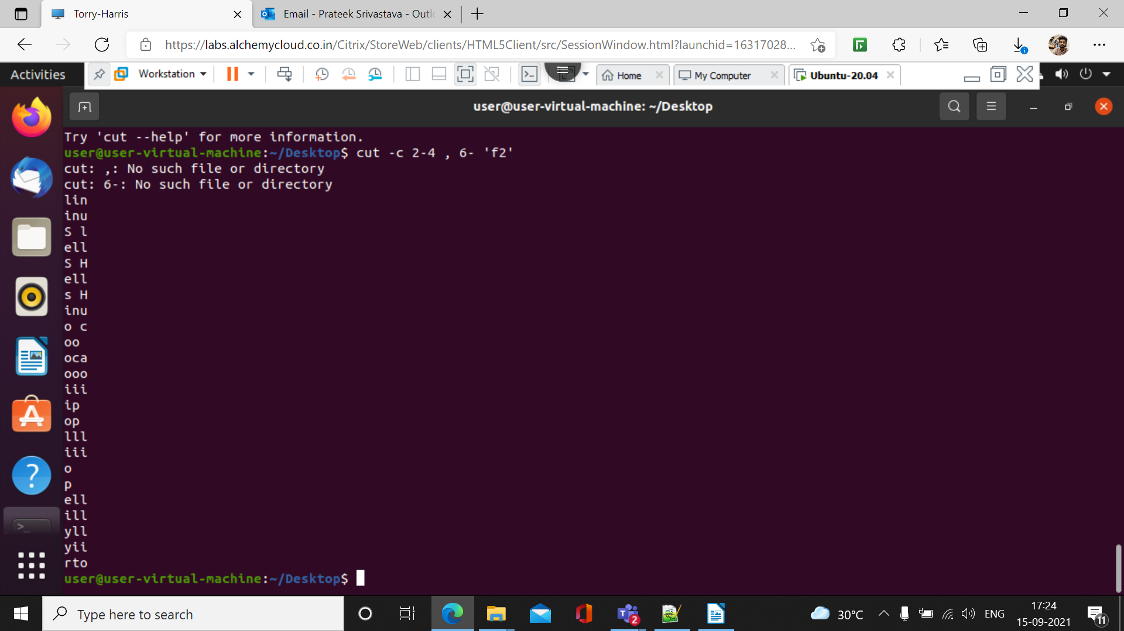

24.) --complement -c 5 – f2

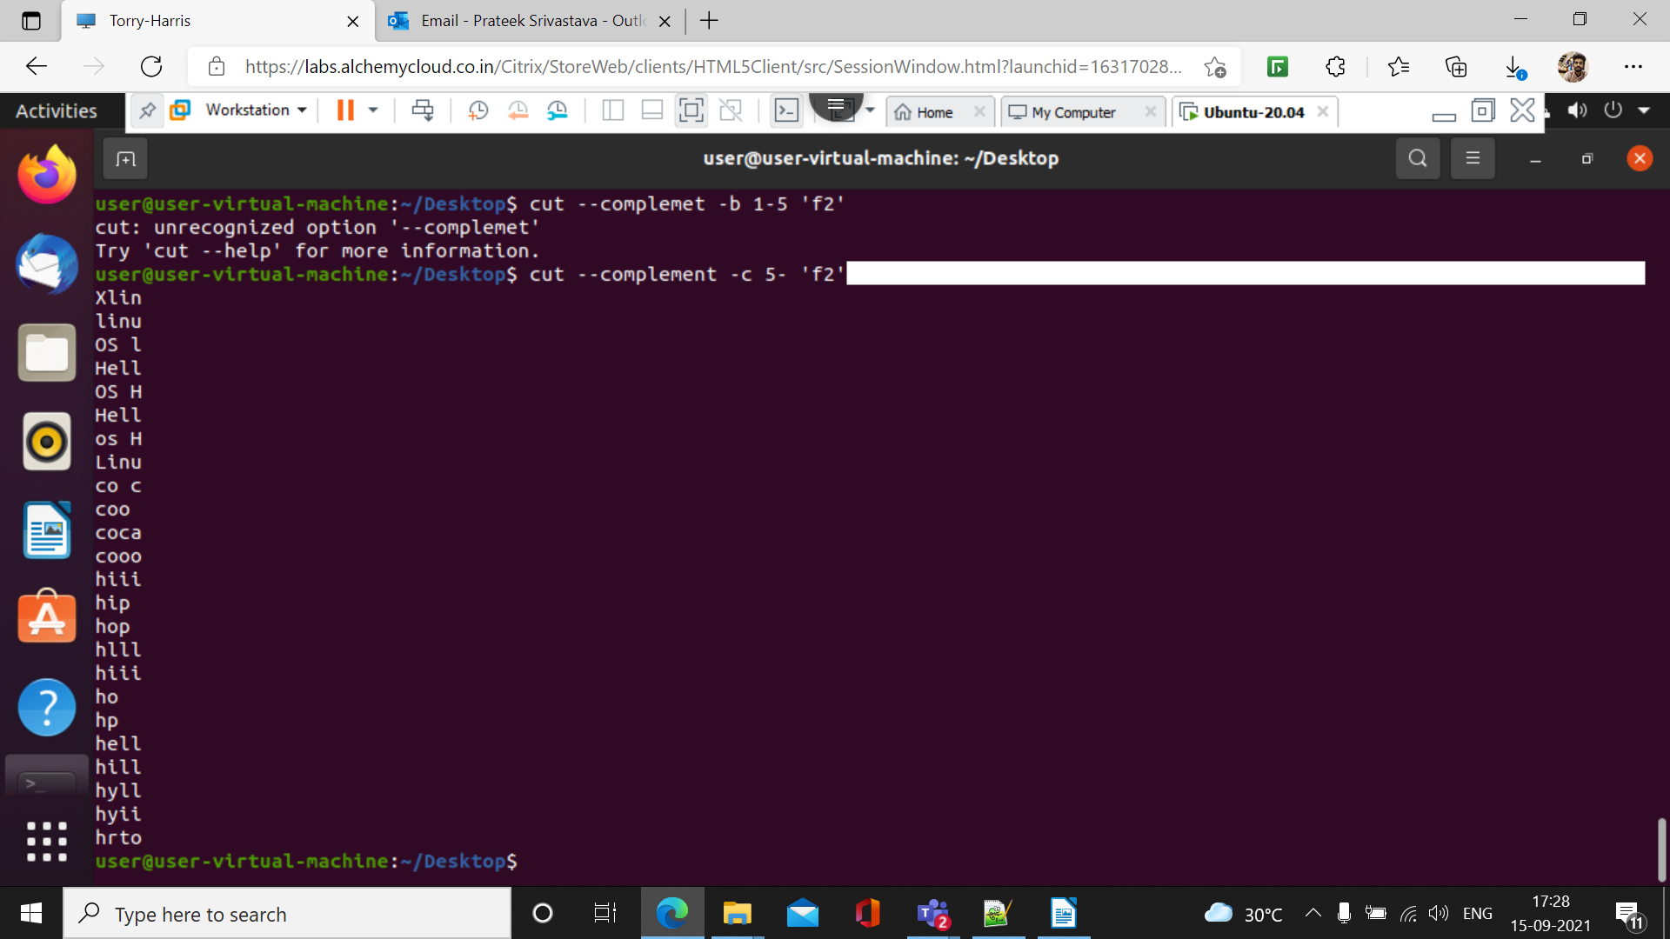

25.)-d ‘ ’ - ‘f2’ ‘f3’

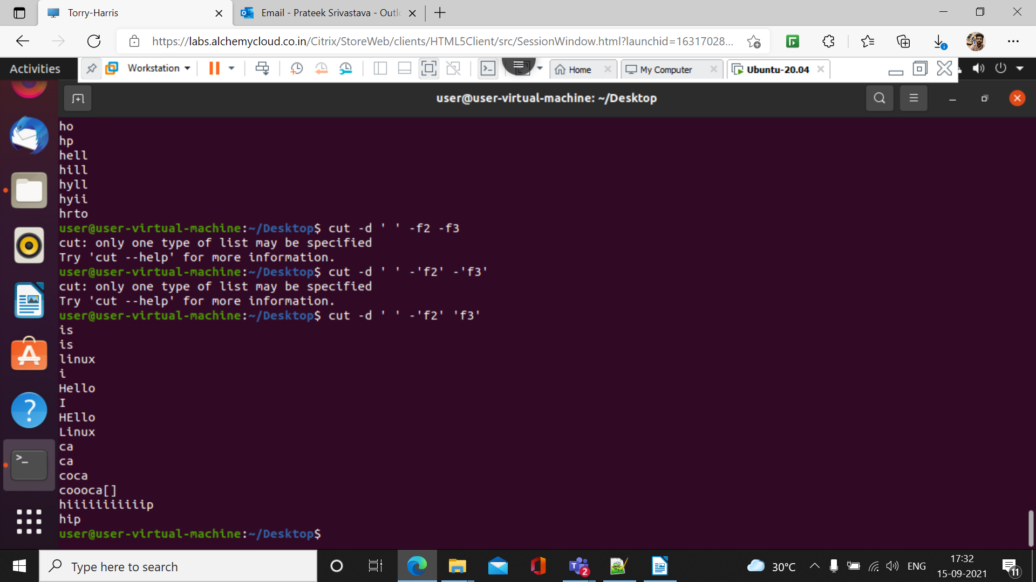

26.)cat f2 | tr ‘[:upper:]’ ‘[:lower:]’

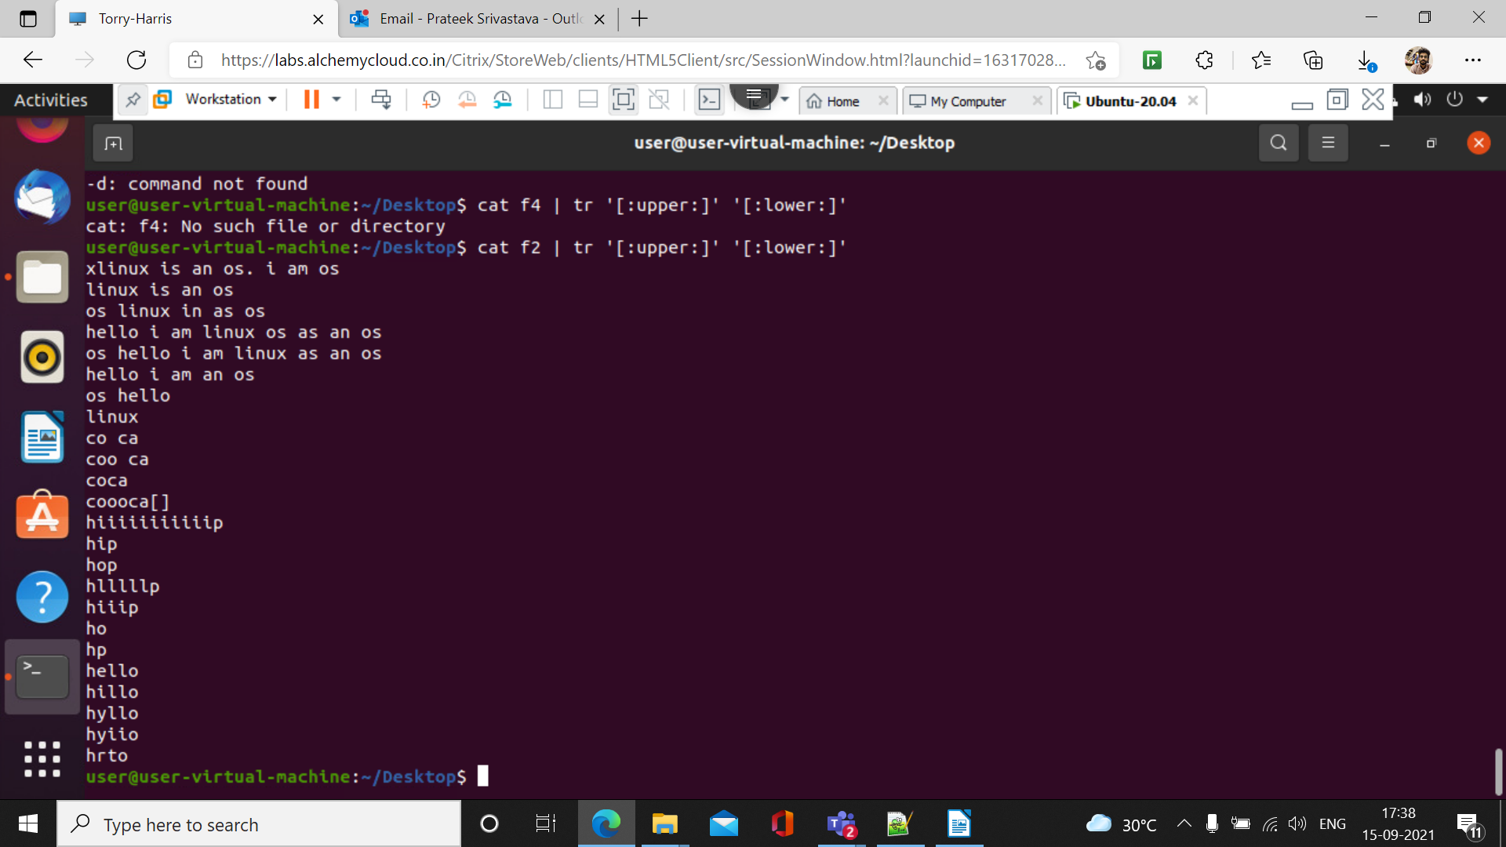
27.)cut f3 | tr ‘[H]’ ‘[O]’

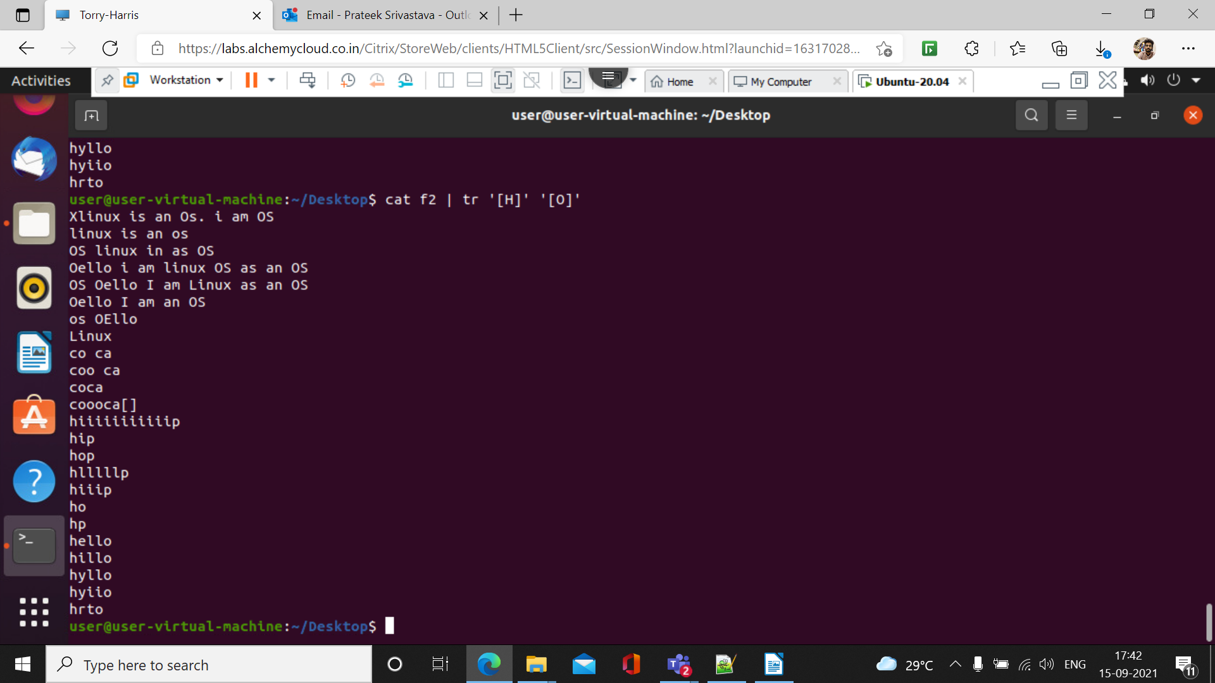

28.)cat f2 | tr -s [:space:] ‘’

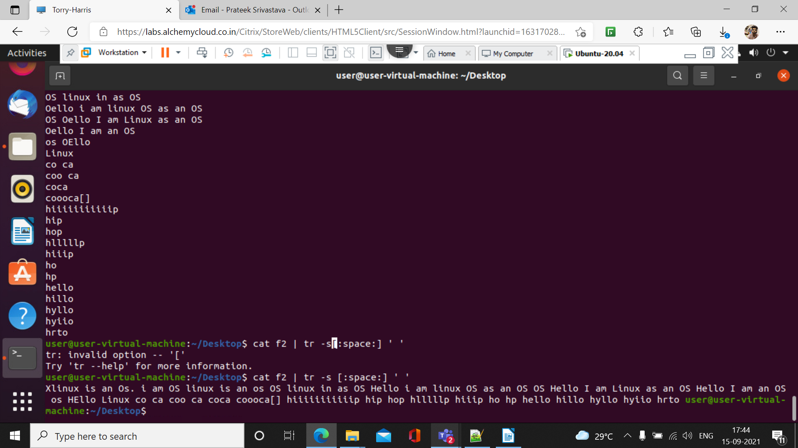

29.) cat f2 | tr – d ‘I’

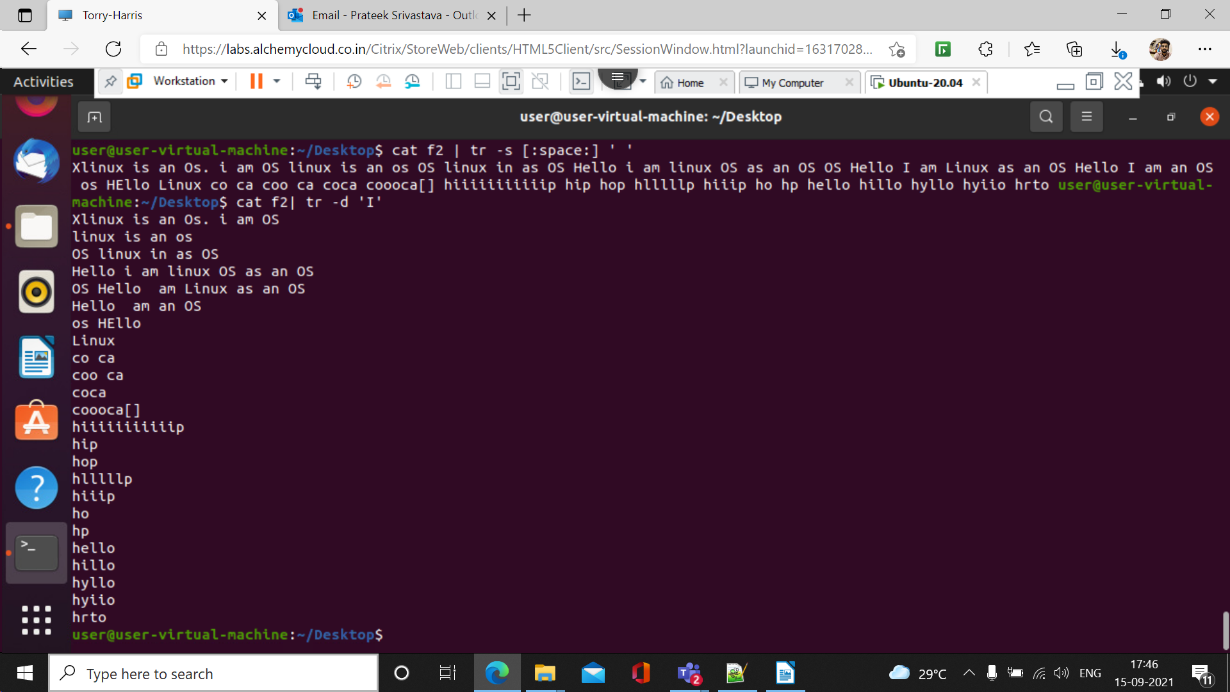
30.) cat f2 |tr -d ‘[A- I]’

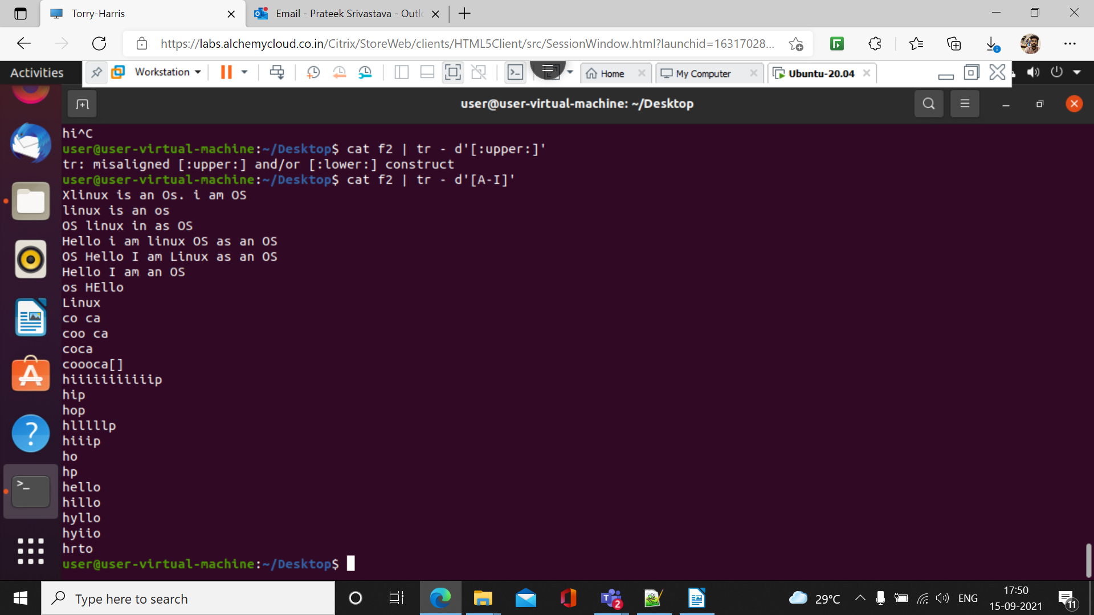

31.)more
more f4

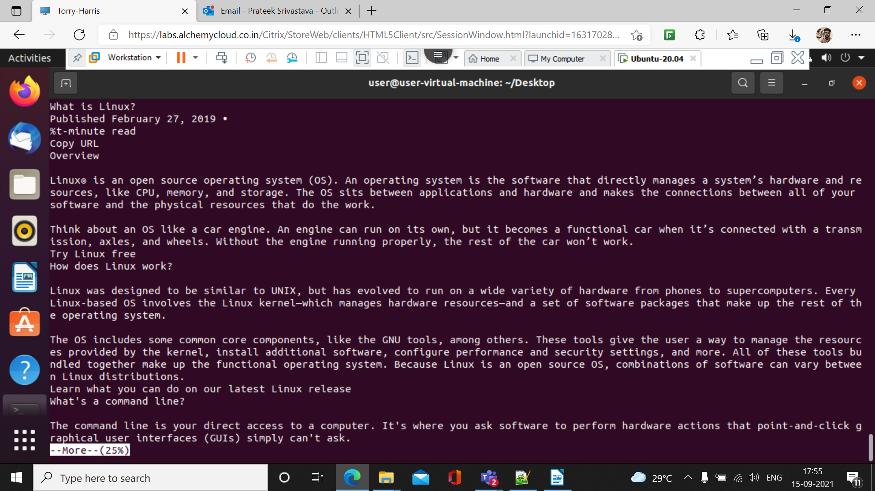

32.) more -p f4
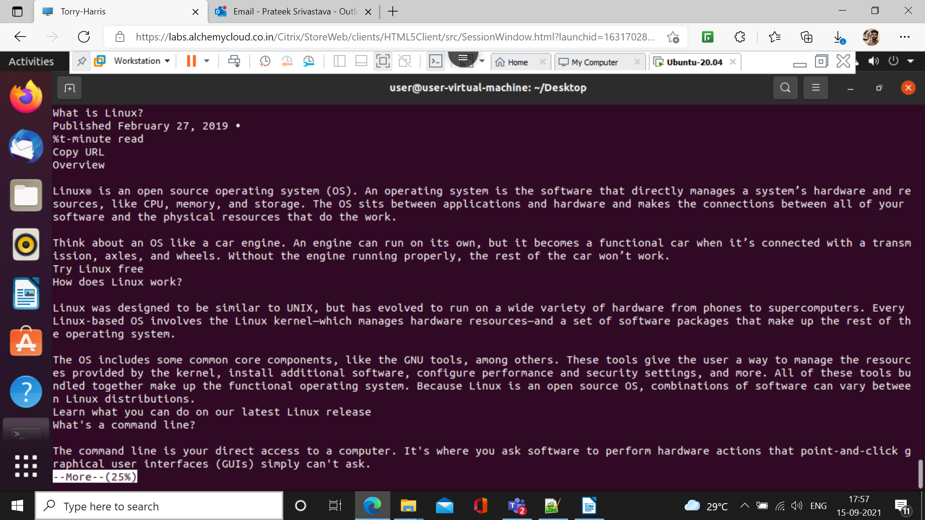
33.) more -s f4


